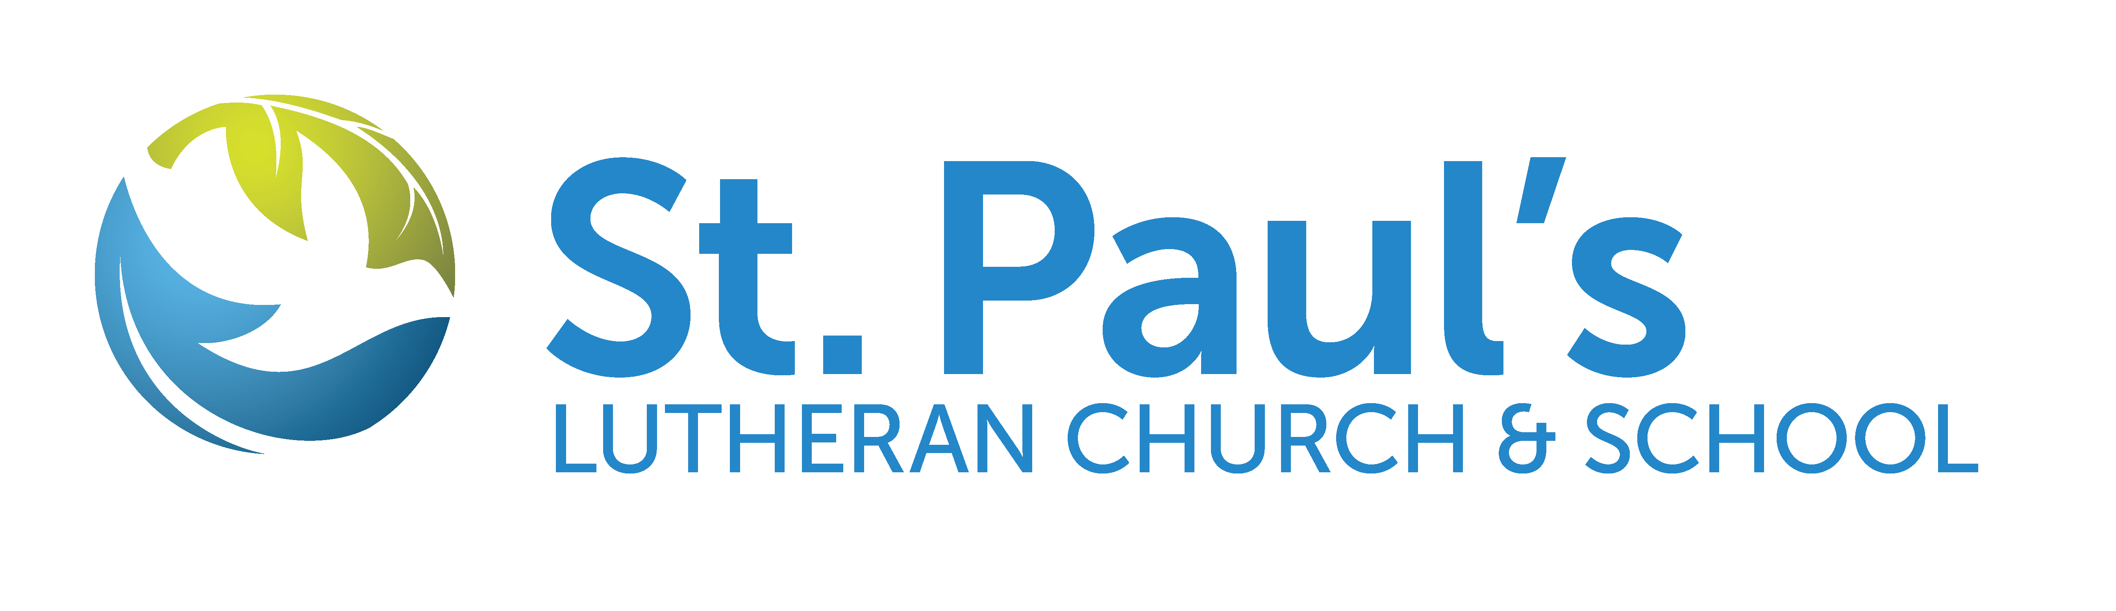
FOR IMMEDIATE RELEASE
10/20/2023

For more information contact:
Deb Bachman
Director of Faith Formation
319-352-3850
Deb.bachman@stpaulswaverly.org

St. Paul’s Lutheran Church & School to Sponsor ELCA Youth Gathering Fundraiser
The group will be selling Christmas Cookie Kits to fund trips
WAVERLY, Iowa— St. Paul’s Lutheran Church & School is sponsoring a fundraiser for the ELCA Youth Gathering organization. The fundraiser will begin on Nov. 26 and will last to Dec. 24, 2024. To help fund future trips, the ELCA will be selling Christmas cookie kits. For more information, contact Director of Faith Formation, Deb Bachman at Deb.bachman@stpaulswaverly.org.
“This fundraiser is for anyone who wants to have Christmas cookies but doesn’t want to bake the cookies. These kits will provide cookies, frosting and a few decorating supplies for you to frost and decorate cookies at home. All proceeds will go towards the youth attending the 2024 ELCA Youth Gathering in New Orleans,” said Deb Bachman.
This is a new event that the youth going to the 2024 ELCA Youth Gathering will be selling cooking decorating kits for Christmas. They will offer presales of kits and some will be
ready to go on Sunday mornings and other events.
St. Paul’s Lutheran Church & School is located in Waverly, IA and is affiliated with the Evangelical Lutheran Church in America (ELCA) in the Northeastern Iowa Synod. It is a place for people of all ages and backgrounds to worship, learn, and grow together in their faith. To learn more about St. Paul’s Lutheran Church & School, visit stpaulswaverly.org.

###

